LAB REPORT

(Names) Bryon Ferrer, Sajana Wijesinghe
(Date) 10/18/18

Title: Lab Number 5
Statement of the Problem:

The question we are trying to answer in this lab session is “How can you use an Arduino microprocessor to get the piezoelectric speaker to play sounds and text?” In order to achieve this, you can send non-ASCII character values to the device by writing the code value for the control functions and then writing the code for the tone.

Materials:
- USB Cable
- Arduino Uno microprocessor
- Parallax 2x16 Serial LCD
- Backlit with Speaker

Procedure:

First, we start off by setting up the equipment. The circuit must be properly setup in order to proceed forward. The image below is an example on how it should be built. And if its properly setup, you should hear some kind of melody.

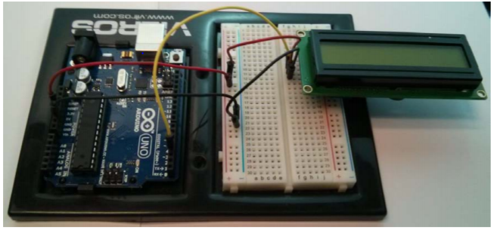

Next, we open Arduino.exe program and start writing the down the code that will make words appear on the Backlit with speaker. The code below represents the everything we need to make the word “Hello World” appear on the Backlit

#include <SoftwareSerial.h>
const int rxpin = 2;
const int txpin = 3;
SoftwareSerial serial_display(rxpin, txpin);

void loop()

void setup() {
serial_display.begin(9600); // setup port at 9600bps
serial_display.write(0x0c); //ASCII Form Feed - clear display
delay(10); //delay required
serial_display.write("Hello World"); //Write Hello World
serial_display.write(0x0d); //ASCII carriage retrn - next line
}

Next, we’ll slightly modify the code in order to make the backlit produce a music of our choosing. So, to do that we’ll add a charge function and also add some code into the loop function. The following code is what we need to add.

void loop() {
delay(2000);
serial_display.write(0xDB);
charge();
}

void charge() {
serial_display.write(0xD2); //set note length to 1/16 note
serial_display.write(0xE6); //G note
serial_display.write(0xDF); //C note
serial_display.write(0xD3); //set note length to 1/8 note
serial_display.write(0xE3); // E note
serial_display.write(0xD4); //set note length to 1/4 note
serial_display.write(0xE6); //G note
serial_display.write(0xD3); //set note length to 1/8 note
serial_display.write(0xE3); //E note
serial_display.write(0xD5); //set note length to 1/2 note
serial_display.write(0xE6); //G note
}

The charge function is what controls what type of sound is being produced. And the loop function is what controls the speed at which the sounds are being produced.

Conclusions:

There are a couple of things I learned from the lab. First, I learned about how serial_display works and what commands to use to play sounds or display text unto the speaker and LCD, respectively. Second, I learned about non-ASCII values and how they associate with notes and octaves. Third, I learned about making circuits with wires and connecting them to the LCD and speaker itself. There are a couple of experimental errors, from not making a proper circuit to sending the wrong values to the LCD and speaker. However, we didn’t encounter these errors.

